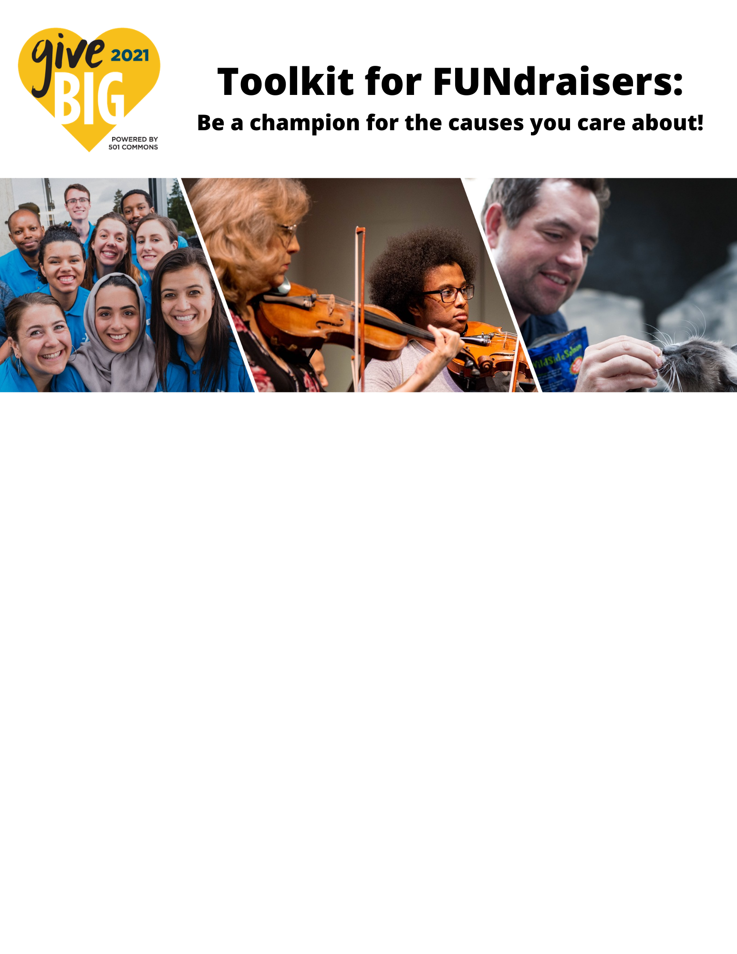

Lead the Way for Your Cause!
You can raise awareness of your favorite nonprofit by reaching out to your friends, family, and colleagues through a FUNdraising page.

- Choose a nonprofit to fundraise for
- Create your FUNdraising page
- Share your FUNdraising page with your network

Every time you share your page by email or on social media, you expand the circle of people who get to know about and support the cause you love. With your leadership, the nonprofit you care about will connect to new donors and champions!

Frequently Asked Questions

Who should I ask to give?
Family, friends, colleagues, neighbors, friends of friends, people you buy services from, and more! Not everyone you ask will donate, but money isn’t the only benefit from FUNdraising. By reaching more people and new audiences, you bring greater awareness to the cause you care about!

Who do I reach out to if I need help?
If you are having a technical issue, you can reach out to the Washington Gives Support Team at givebig@501commons.org. If you have a question related to the nonprofit you selected, reach out to them directly.

Create Your FUNdraising Campaign

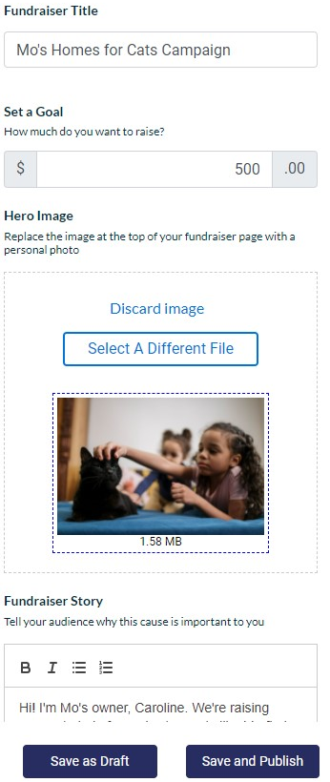
Personalize your page
- Go to www.givebigwa.org
- Use the search bar to find your nonprofit or cause.
- Click the FUNDRAISE button

- Enter your FUNdraiser Title:
Give your page a short and attention grabbing title. Personalize it to your story and why you are fundraising

- Enter your Goal:
Think about how many people you will ask and estimate how much they may be able to give. Ex. 100 people x $10 = $1000! You can always adjust your goal later.

- Upload a Hero Image:
Add a compelling image of you or those the nonprofit helps. The image should be good quality and clear. Hopeful images with faces have the most impact!

- Write your Fundraiser Story.
It should include your connection to the nonprofit, their cause, and why you give. Your personal story is the most compelling reason for your friends and family to give!
You should ask directly for a donation, thank your supporters, and ask they also share your page.

- Publish your page.
You’ll be asked to create or login to a donor account, which you can use to edit your page later. Make sure to copy the page’s url to share with potential donors.

Campaign Strategies
- Set a challenge: Offer a reward for your donors if you meet your fundraising goal. You can promise to shave your beard, throw a party, or set out to finally climb Mt. Rainier!
- Start a friendly competition: Pair up with another person doing a FUNdraising campaign to see who can meet their fundraising goal first.
- Connect your campaign with a personal event: Encourage people to donate in honor of your birthday, in memory of someone, or to celebrate a milestone.
- Make it newsworthy: Connect your campaign with a topical news story, holiday, or an event connected to your cause.
- Seed success: Other people are more likely to donate to your campaign when they see that someone has already contributed, so encourage your most likely supporters to give early!

Sharing Your FUNdraising Page

Where to share?
You know your network best. Use the social media where you spend the most time with the people you know! Personal emails and direct messages are the most effective.

What and when to share?

ASK: When your campaign starts
- Keep it short, personal, and direct. Your connection to the nonprofit you give to and why you give will encourage others to give.
- Create urgency by including the last day to give. You don’t want your supporters to forget to donate!
- Ask them to give and share your page. Asking for a specific amount is shown to drive giving.

REMIND: Before your campaign ends
- Thank those who have given and remind everyone to give and share.
- This message can include your story, facts about your cause, and how close you are to your goal.

THANK: When your campaign ends
- Thank donors with a general public message. This is one last chance to increase awareness!
- Thank donors directly with a personal email, call, or text.

Don’t forget to:
- Use your custom URL in all your messages.
- Use the hashtag #GiveBIG between April 20 – May 6.

Resources
- GiveBIG Logos and Graphics
- Donor FAQ

Thank you to Third Sector Company for sponsoring this toolkit!
Since 2002, Third Sector Company has helped nearly 700 nonprofits to advance strategic leadership continuity solutions for their organizations, associations and congregations through interim executive training, placement and support, executive search, CEO performance planning and reviews, Board Chairs Academy, and succession planning services.

